**Signal Detection**

Course name- PSY310: Lab in Psychology

Date- 1/09/2023

Name- Rishitaa Joshi

Enrollment no.- AU2120095

**GITHUB:**

**Introduction**

In a signal detection experiment you define what is your signal and what is your noise. Signal detection theory (SDT) is a theoretical framework for studying how humans react to stimuli. According to the notion, people notice things based on how strong they are and how much attention they pay. The theory also takes into account how people evaluate the strength of a signal and their confidence in making a decision based on what they have discovered.

SDT is founded on the notion that humans can detect important information, or "signals," in the midst of chaotic and ambiguous inputs. The idea investigates how people make decisions based on the intensity of a stimulus as well as their physical and psychological state. SDT was created in order to study the behavioural responses of mammals, particularly humans. John A. Swets and David M. Green utilised it for psychophysics in 1966.

**METHOD**

***Participant***

The participant was female and the age was 20 years. The participant had normal vision and is a part of Ahmedabad University.

***Materials and procedure***

The experiment was designed by using a python based software, Psychopy. The experimenter was provided a video explaining how to design the visual grating task by the professor of the course. The materials used by the experimenter was their personal laptop. .

In the task, a stimulus of 1 second was added in the beginning , after which a polygon in the shape of a triangle was added. The duration of the polygon was 1 second. A grating stimulus was added as well to the task whose orientation tilt was set every repeat and spatial frequency was 5. The participant was supposed to press down when they observed a tilt and to press the up key when they did not observe a tilt. A python code was added at the beginning of the experiment and at the end of the experiment. The python code was added at the end of the experiment so as to collect data about the key response made by the participant, the correct key response and the tilt.



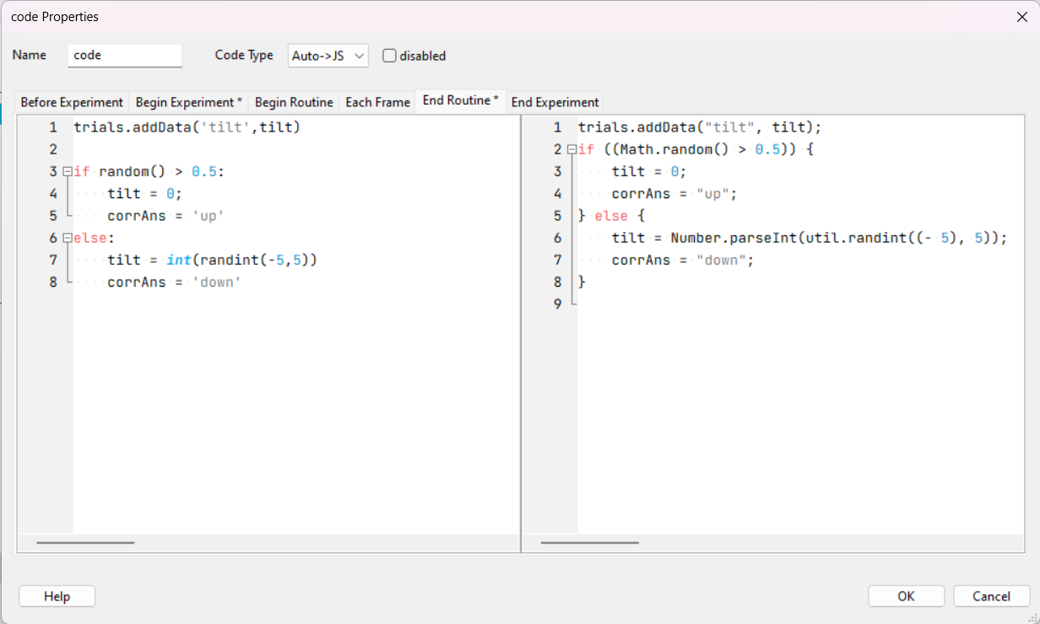



***Results***

After collecting the data, hit was found to be 94, miss was 13, false was 16 and correct was 68. Prop hit was found to be 0.878505 and prop false was found to be 0.190476. Finally the d prime was 2.043687 and c was -1.60562

**DISCUSSION**

You make four categories based on whether the signal was absent or present and on whether the participant responded yes or no. A signal refers to a vertical gabor, A signal absent means that the gabor is tilted and 0 tilt is signal present. These categories would be hit when the signal was present and the participant’s response was correct, miss if the signal was present and the participant’s response was false, false alarm if the signal was absent and the participant responded yes and correct rejection if the signal was absent and the participant’s response was no.

Signal detection can be helpful in examining how individuals adopt different decision strategies in response to varying levels of uncertainty or difficulty in a task. On the other hand, a limitation of SDT can be that it assumes that signal and noise distributions are gaussian, which may or may not be true in real world situations. This can limit the accuracy of SDT in certain contexts. SDT is designed to measure binary responses and this may or may not be adequate when we wish to capture the complexity of particular decision making scenarios. To conclude SDT is a significant tool for quantifying the perceptual sensitivity and response bias in various areas, but its limitations should be considered when it is being applied to particular research experiments.

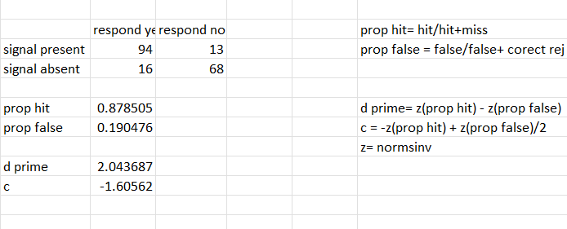

**REFERENCES**

Hansen, M. (2016). PyVDT: A PsychoPy-Based Visual Sequence Detection Task. Journal of Open Research Software, 4(1), e22.DOI: <https://doi.org/10.5334/jors.117>